

**Submitted by: Submitted to:**

**NAME: Rahul Gusain Hitesh Kumar Sharma**   
 **SAP: 500084143**  
 **ROLL NO.: R214220900**  
 **BATCH: 1 DevOps**

EXPERIMENT 5

**Aim :- Working with Dockerfile to Build and Push Docker Image**

1. **Create the following Dockerfile**

FROM alpine  
 MAINTAINER SUDIPT  
 RUN apk update  
 RUN apk add nodejs  
 RUN mkdir /app  
 COPY index.js /app  
 WORKDIR /app  
 RUN node index.js

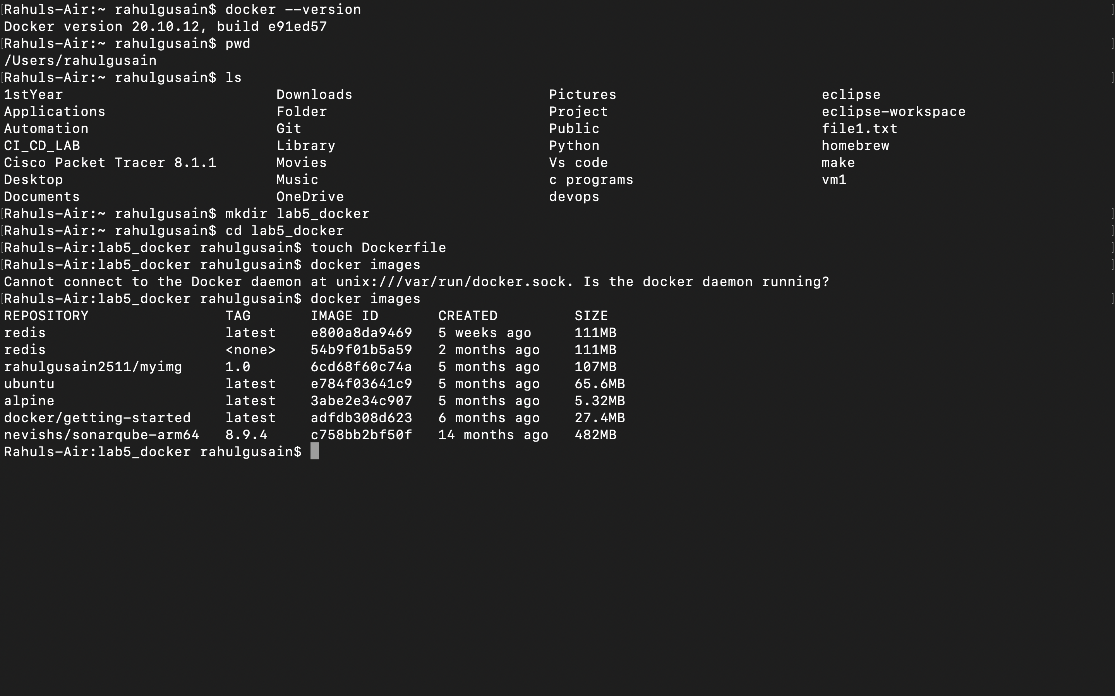

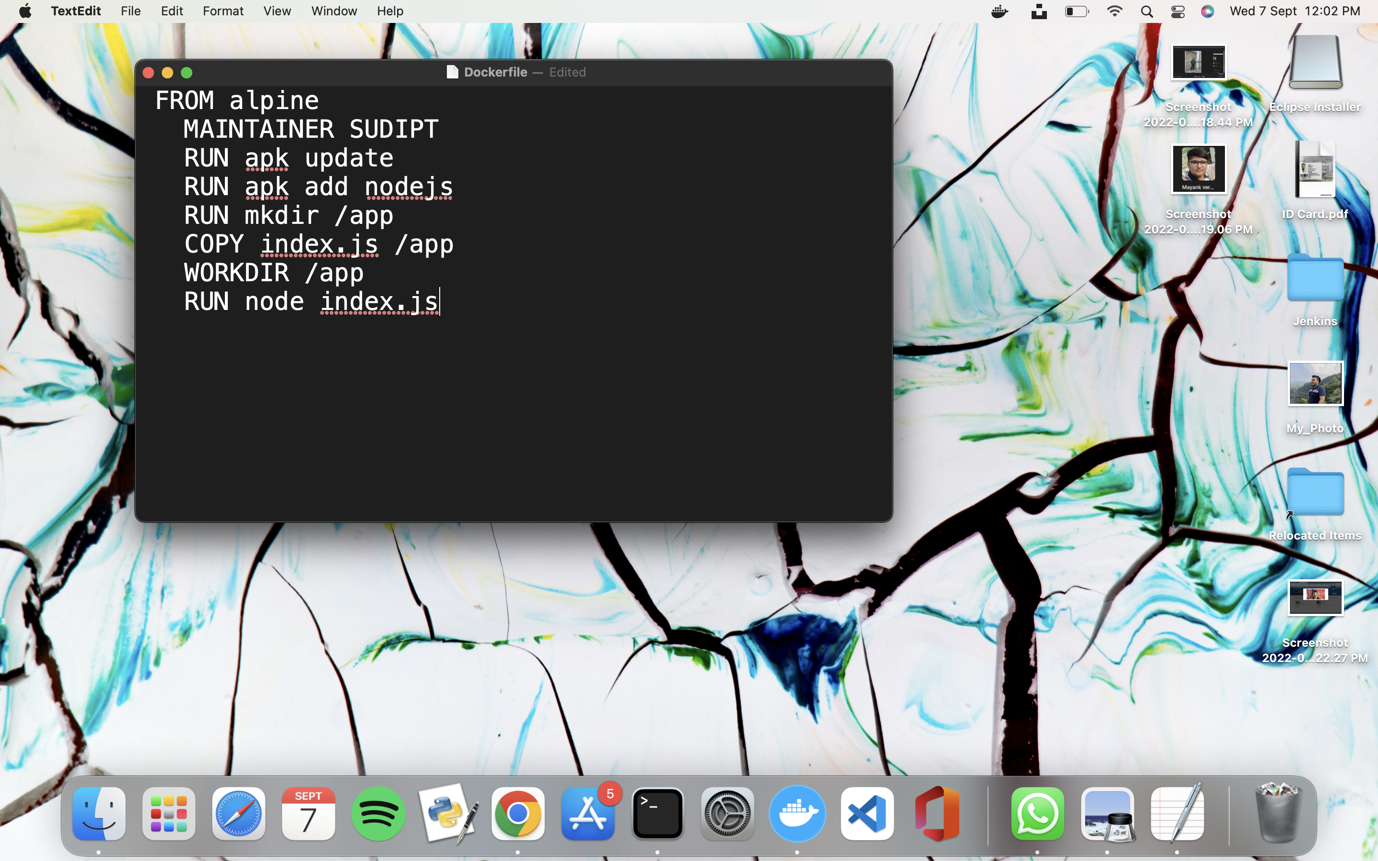

1. **Now we have dockerized the app, we will Build image from Dockerfile.**

docker build –t myimage:0.1

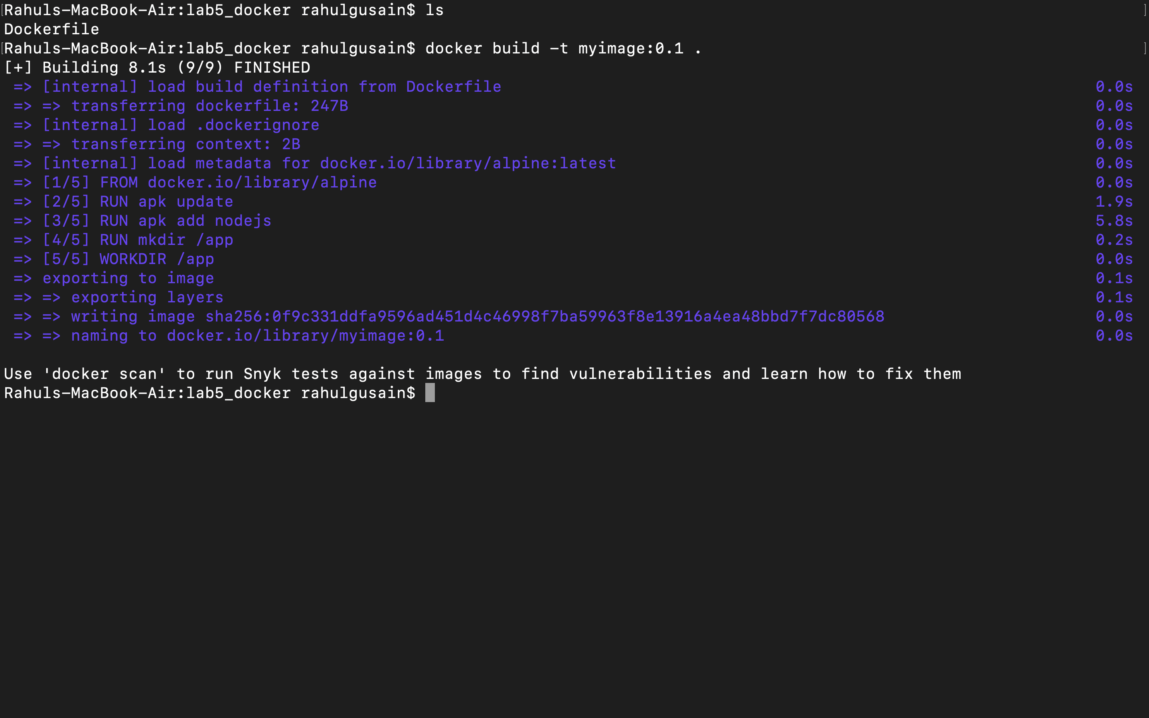

1. **Create an account on Docker hub and create a repository in it.**

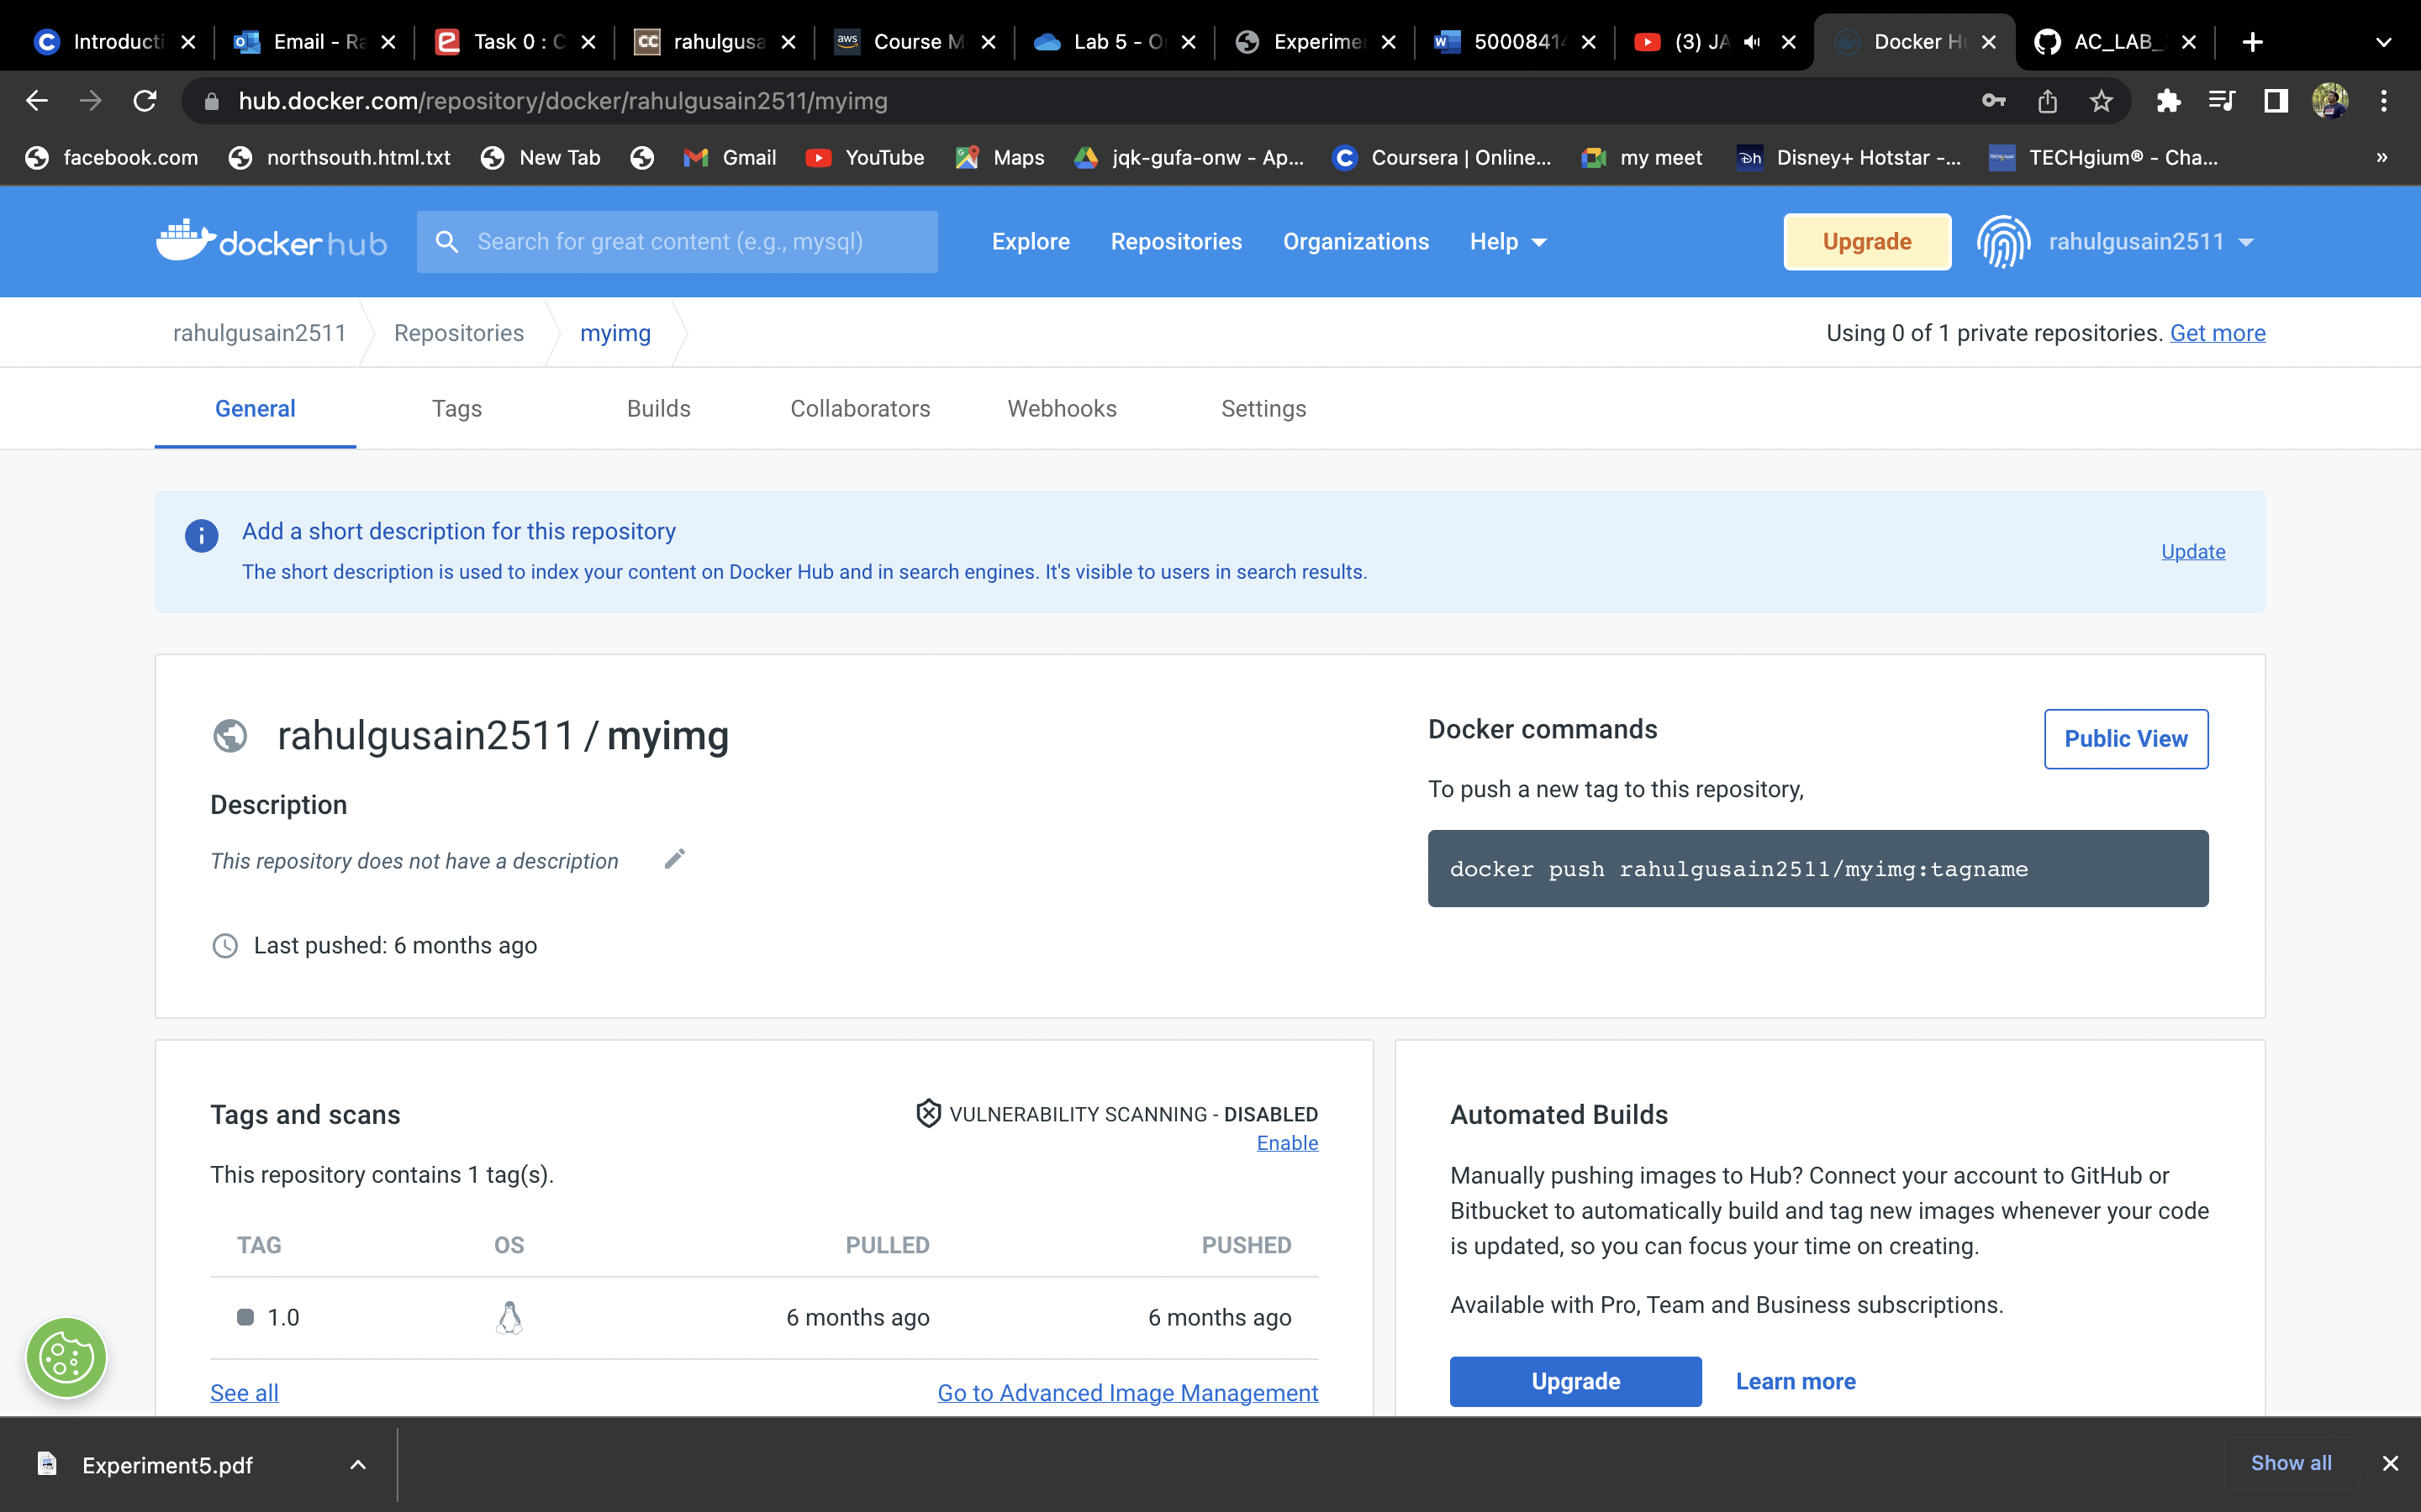

1. **Tag the recently created image using following command.**

docker tag 8fe67b57c3d46951361aa1a52801366e7bc1

Rahulgusain2511/alpine

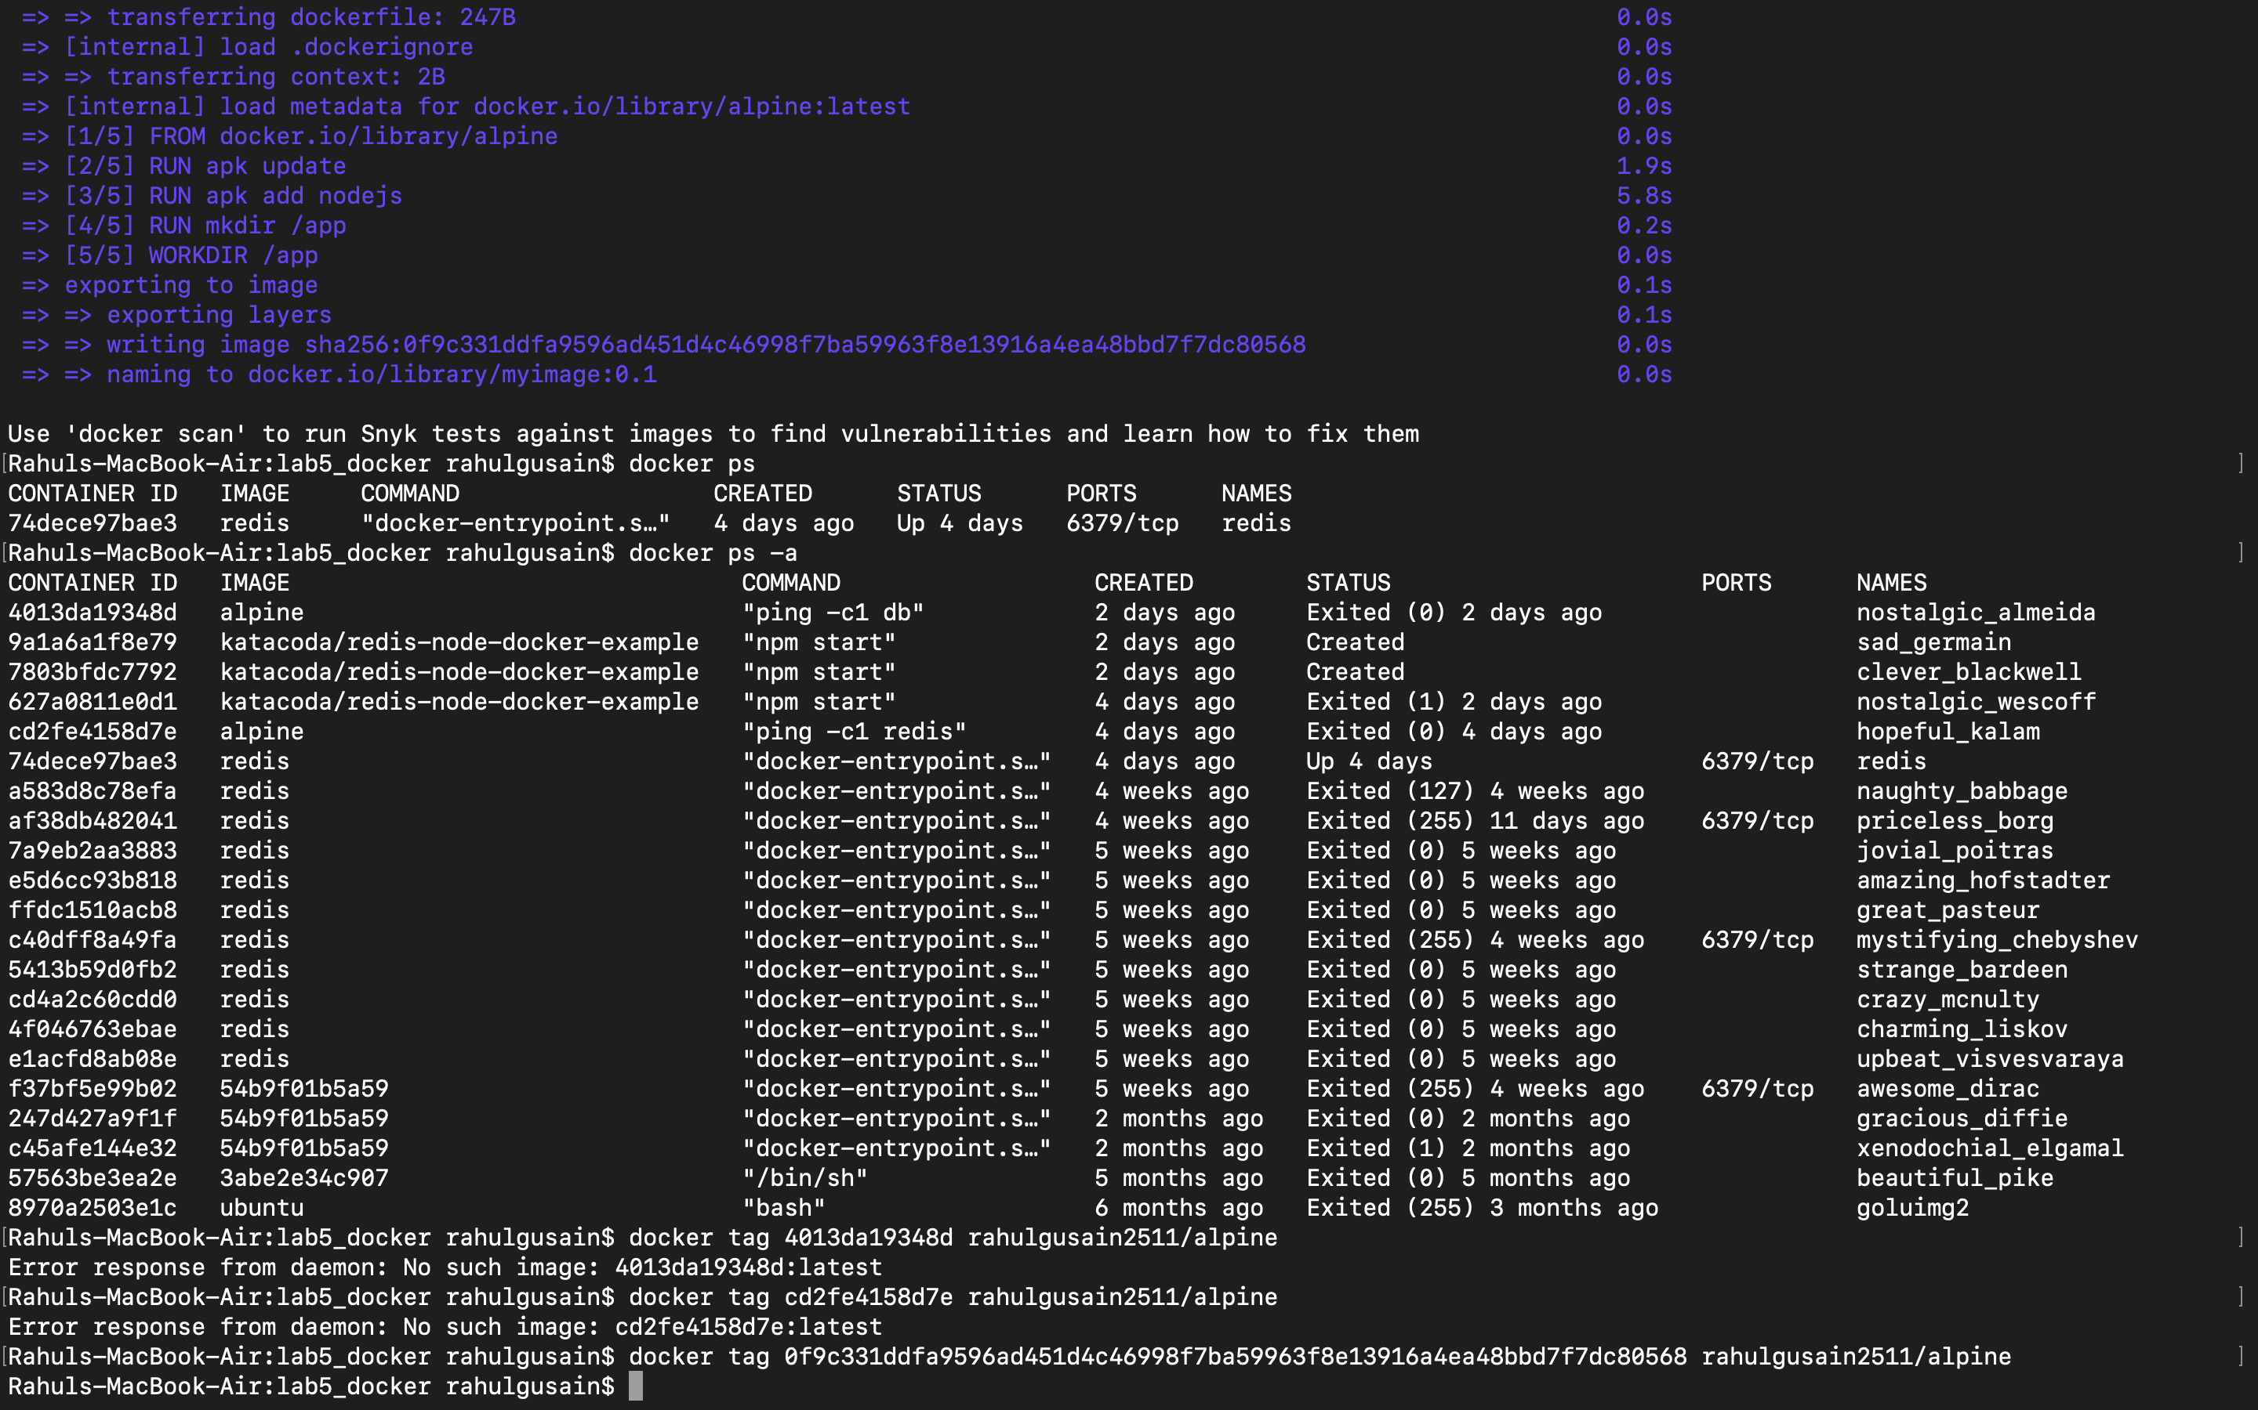

1. **Login to Docker hub from console using following command.**

docker Login

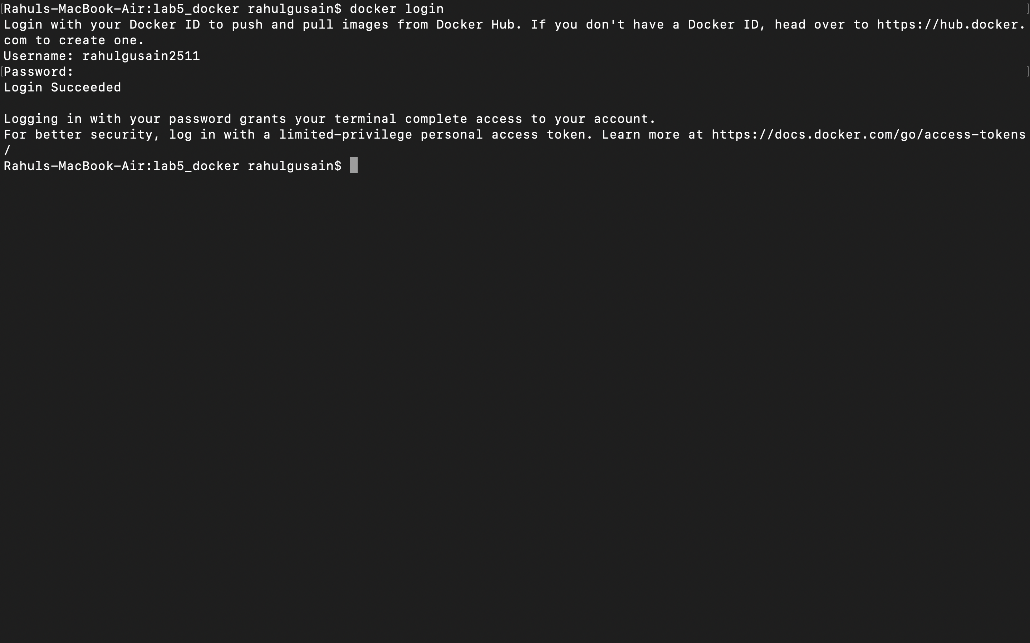

1. **Now push the image on Docker hub using the following command.**  
   docker push rahulgusain2511/alpine

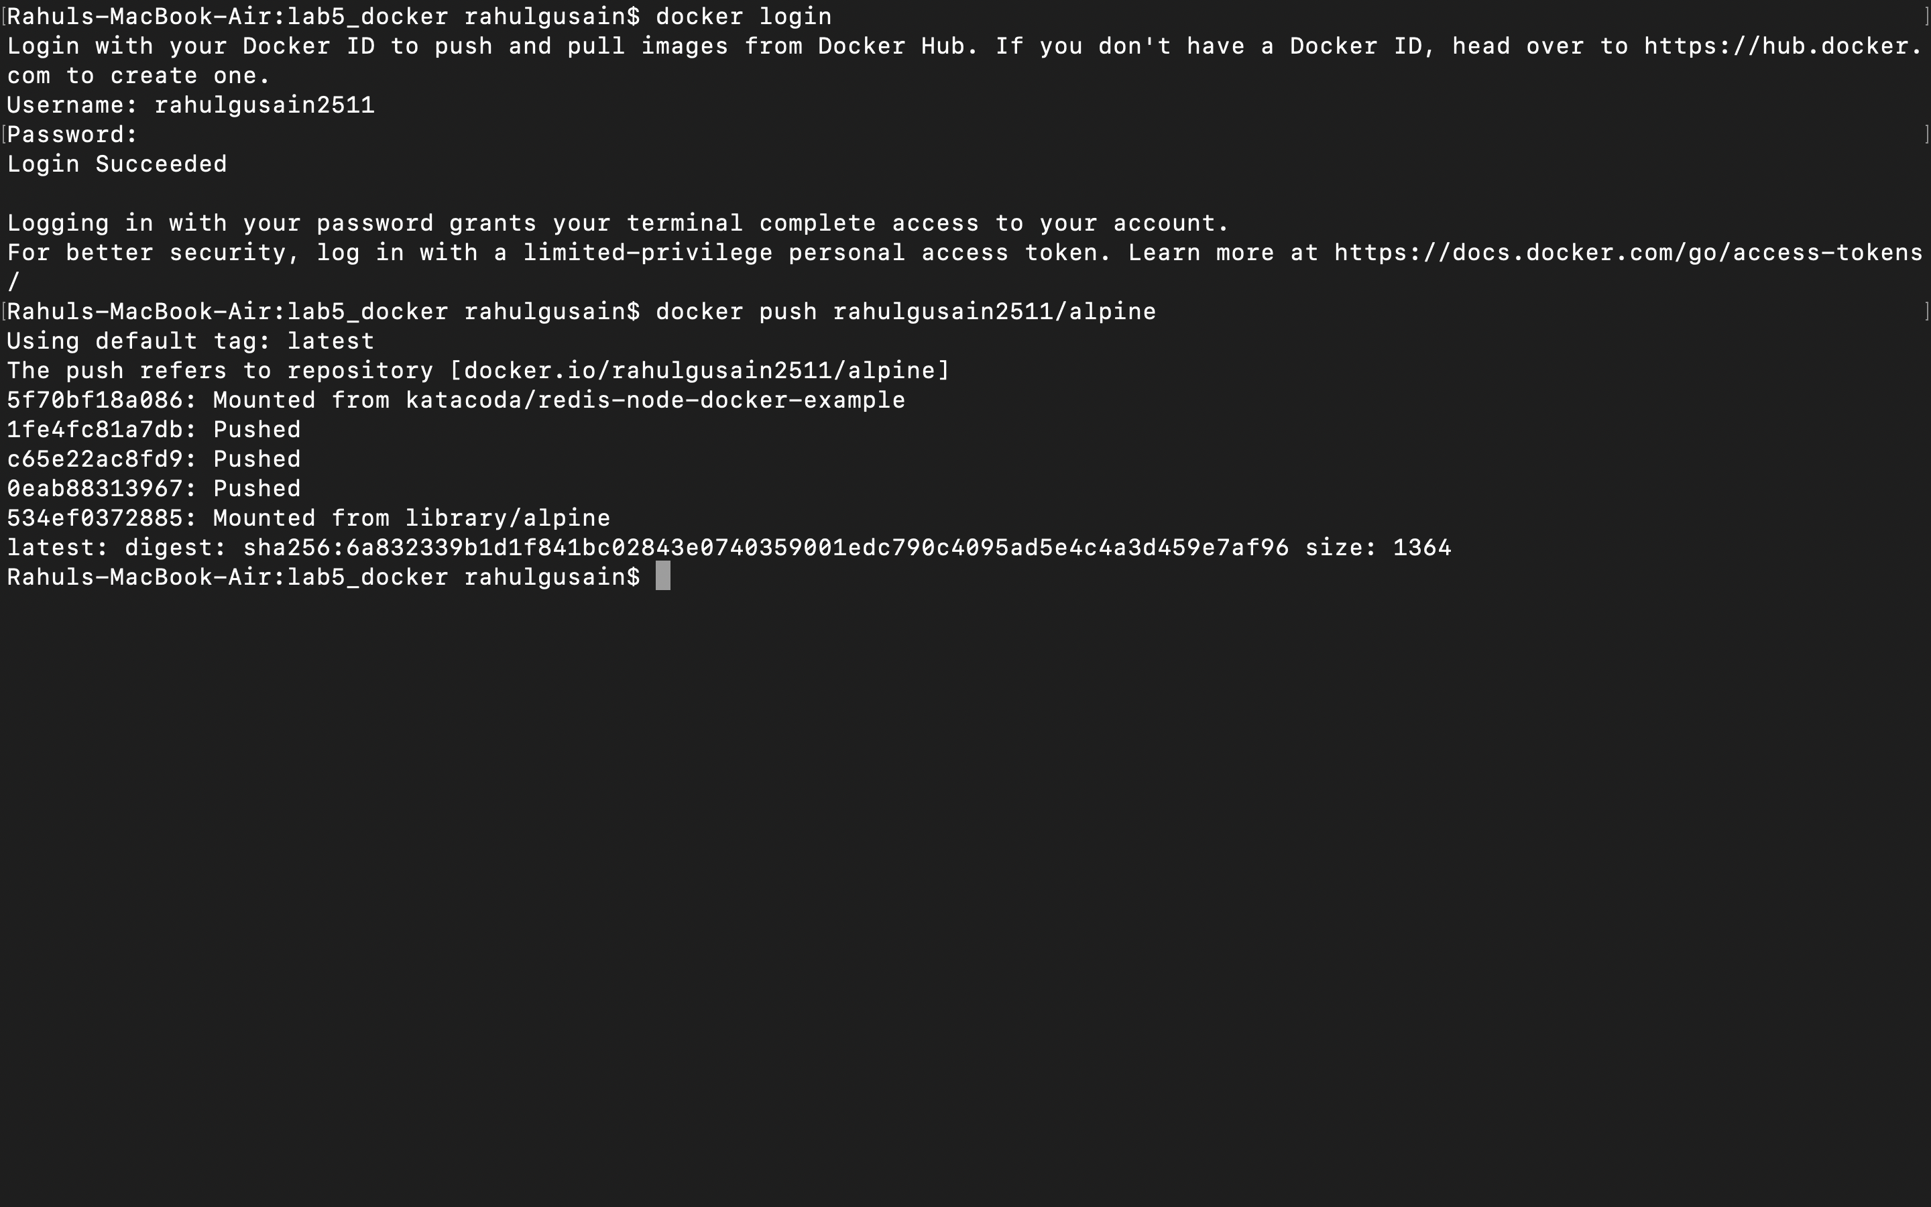

1. **Pull and run the container of your deployed image on docker hub.**

docker run –d rahulgusain2511/alpine rahulgusain2511/alpine rahulgusain2511/alpine

